Energy & Environment

Summary based on the lecture slides

by MArtin Winter

2016

Contents

Introduction 2

Initial situation 2

Global Agenda 2015 2

World Energy outlook 2

Global Energy trends 3

Access to Electricity 3

Sustainability 4

Environmental Economics 4

Aspects of sustainable development 5

Natural vs Antropogenic capital 5

Ecological sustainability 5

Economic Sustainability 6

Social sustainability 6

CSR 6

Ecological Footprint 6

Environmental targets in companies 7

Cleaner Production 7

Climate Change 10

Emission Trading System 14

Life-Cycle Analysis 18

Environment Management System 24

Directives 26

Acceptance 28

# Introduction

## Initial situation

Today, about 7.3 billion people live on this planet and still more than 2 billion are without access to energy as poverty remains a global problem with big differences in the distribution of wealth. Additionally, more and more people live in so-called mega-cities with more than 5 million people per city.

But not only the population is growing, with it there is also rapid growth in energy demand that leads to some societal challenges, that include **local** and **global environmental pollution**, **limited resources** and also the **societal acceptance** and **risk aspects** connected to such a growth in energy providers. Typically, 1% increase in population leads to an 1% increase in emissions. The population is growing nearly everywhere, except for the European union, this leads also to a population pyramid that isn’t a pyramid at all any more, more like a vase that keeps getting bigger at the top and shrinking at the bottom. Compared to that India has a much larger base population that may be able to sustain their elderly population.

## Global Agenda 2015

This is an **analysis** of the **top 10 trends** and takes key regional challenges and emerging issues into account that will define our future, these trends include the **rising pollution in the developing world**, the **increasing occurrence of severe weather events** and the **increasing water stress**.

#### Rising pollution in the developing world

Developing countries will suffer most from weather-related disasters and increased water stress caused by global warming, these countries are expected to bear up to 80% of the impact costs of global warming.

**Solutions** include investing in a cleaner power generation network, ensuring proper regulation and promoting clean energies, funding provided from richer countries and also cooperation to develop new low-carbon technologies. The problem always is that high carbon solutions, once implemented, are difficult to replace, therefore decisions being made today on power generation are crucial.

The cost of the increasing occurrence of extreme weather events will be highest for society’s poorest as well as the increasing water stress that will rise quite extraordinarily.

##### emerging Nuclear powers

Electricity demand in developing countries is increasing by about 5% per year, because of that alternatives to meet the electricity demand have to be found, for example nuclear power.

## World Energy outlook

The **International Energy Agency** is an autonomous agency the tries to **promote sustainable energy policies**, **improve transparency** of **international energy markets, support global collaboration** on **energy technology** and also **find solutions** to **global energy challenges**.

It takes a look different scenarios, principally the **current policies scenario**, the **new policies scenario** and also the **450 scenario**, that tries to keep the CO­­­­­­­­­2 concentration below 450 ppm eq. The biggest contributors are China, USA and India.

The power sector offers the largest possibility for additional abatement, now about every third power plan of new capacity was low carbon, to meet the 450 scenario would mean that this needs to shift to 3 out of 4 after 2030.

### Global Energy trends

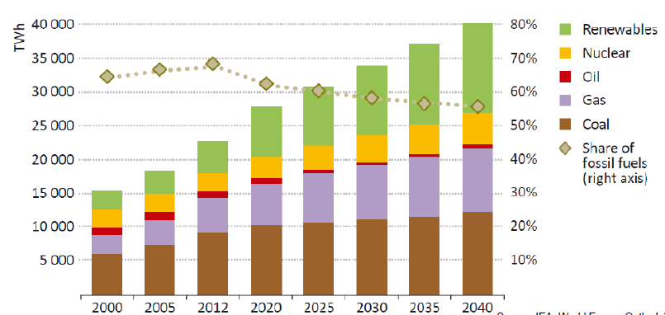The energy demand is expected to increase by 37% according to the new policies scenario or even 50% according to the current policies scenario in the next 30 years, almost all of this increased demand comes from Non-OECD countries. In general, the share of fossil fuels in the energy mix is expected to fall while the share of low carbon fuels should increase, but in total the world oil supply is also expected to rise.

#### Market outlook

Electricity remains the **fastest-growing** final form of energy and will nearly double until 2040, also gas and nuclear will replace the share of coal and oil while the share of renewable energies should nearly triple until 2040.

**Renewable energy** is rapidly increasing and driving up its share, wind power capacity additions are the second largest behind gas fired plants while PV gets the largest increase among RE with the EU remaining the largest financial supporter of RE.

### Access to Electricity

Energy poverty is still widespread, in some African countries only 15-30% of the population has access to electricity.

# Sustainability

## Environmental Economics

As humans cause environmental impacts, it is important to look at the **relations** of a company to its natural environment, assess the **effects on the environment** and work on an **environmental policy** for the company. The goals are always to **reduce input and output** and guarantee a ration supply of scarce goods. The following principles should hold

* **Precautionary principle:** Avoid ecological damage
* **Principle of origin:** Avoid environmental impacts where they occur
* **Sustainability principle**
* **Polluter pays principle**
* **Cooperation principle:** Cooperation of all relevant public, social and private actors
* **Cross-Cutting principle:** Environmental

There are two ways of controlling this, either by **direct behavior control** (via laws, authorizations, obligations…) or by **indirect behavior control** (taxes, subventions, certifications…).

Sustainable development is defined as

*Development that meets the needs of the present without compromising the ability of future generations to meet their own needs.*

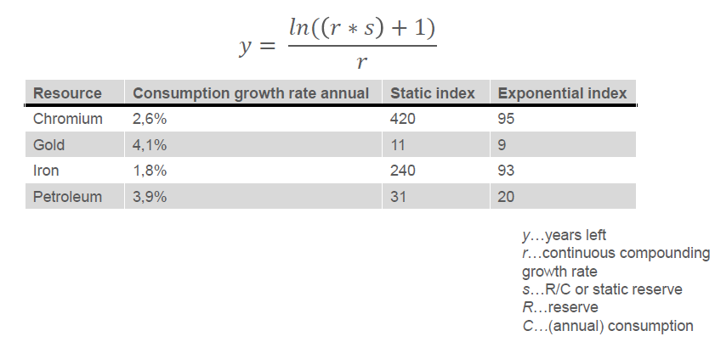It contains 2 key concepts, the concept of **needs** and the idea of **limitations**. Itself as a concept is documented since the early 12th century and started out in forestry.

#### Club of Rome: Limits to Growth (1972)

This is a simulation of exponential economic and population growth with finite resource supplies that concluded, that absolute growth limits are reached somewhere in the next 100 years.

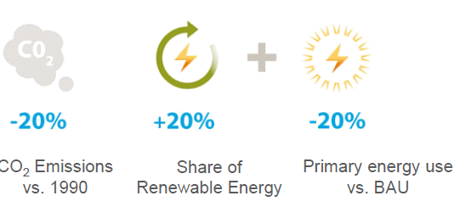The exponential reserve index is defined as the amount of time left for a resource with constant consumption growth.

#### International climate targets

The EU set up the so-called 20-20-20 targets, the goal here is to limit global warming to 2°C above the pre-industrial level, in 2010 all member states committed to this goal, the problem remains, that to reach this target, between 2045 and 2060 all GHG emissions have to be 0.

With the newest agreements from Paris, global warming would preferably be limited to 1.5 °C.

## Aspects of sustainable development

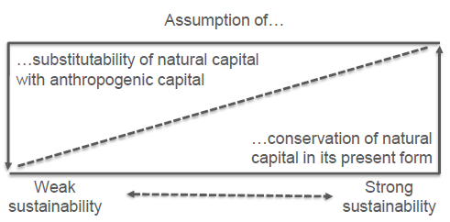Sustainable development tries to establish **intergenerational** and **intragenerational equity**, ensure the **regeneration capacity** of renewable resources, **preserving** the **absorption capacity** of the environment and ensure the **protection of species**.

### Natural vs Antropogenic capital

**Substitutability (weak sustainability)** allows the natural capital to decrease if the anthropogenic capital is created instead, the **complementarity (strong sustainability)** sees a dependency between the anthropogenic and natural capital. 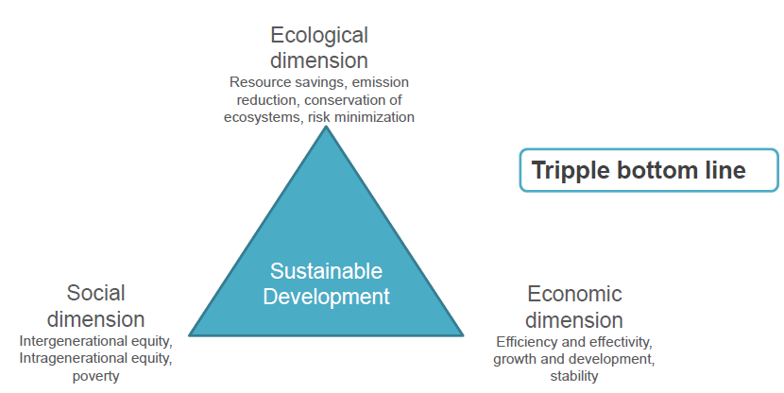

## Ecological sustainability

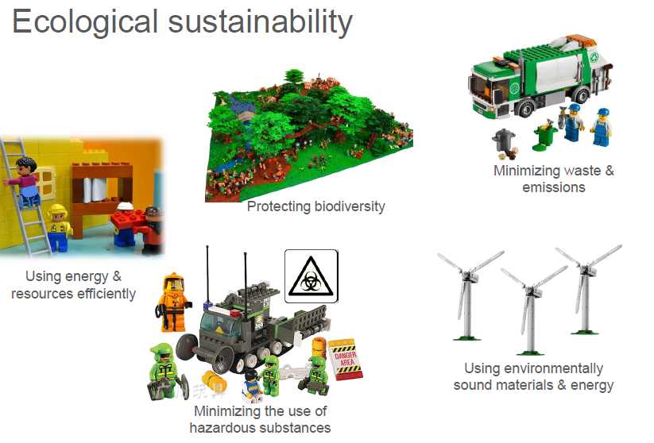The **degradation rate of renewable resources** should not exceed their regeneration rate, this corresponds to the requirement of maintaining ecological functionality, hence to preserve the ecological real capital. **Non-renewable resources** should only be used to the extent in which a **substitute** in the form of renewable resources is provided or the **productivity of renewable and non-renewable resources** is **increased**.

**Infiltrated substances** into the environment should be based on the **carrying capacity** of environmental media and the **duration** of the anthropogenic interventionsmust be weighed against the reaction time for stabilization. **Hazards** for human health are to be **avoided**.

## Economic Sustainability

The economic system should **satisfy** individual and social **needs**, therefore it should **promote** personal initiative (**individual responsibility)** and self-interest in the common good (**regulating responsibility)**, by that **prices** should undertake a **leading function** on the market in **reflecting scarcity** of resources.

Framework conditions have to be designed so that **functioning markets** are preserved, **innovations** are stimulated and **long-term orientation** is worthwhile and that social change is **encouraged**. The **economic capacity** of a society must at least be maintained and at best increase quantitatively and qualitatively.

## Social sustainability

The goal is to reward **social responsibility** throughout the product life-cycle, this can be achieved by proper management of **human resources**, **regional** responsibilities of companies and by **integrating** concerns of **stakeholders**.

**CSR** (Corporate Social Responsibility) relates to the question of the fundamental task and purpose of the company, its guiding principle assumes that companies **not only have to complete economic tasks** but also fulfill tasks and assume responsibility beyond this.

## CSR

CSR has two definitions, in the European union it is defined as **Corporate Sustainability Responsibility** and in companies also the social dimension of the corporate activity is incorporated.

*CSR is a concept which serves companies as a basis to* ***integrate voluntary social and environmental concerns*** *in their business activities and in interactions with their stakeholders.*

If CSR is understood in a broad sense, then social responsibilities apply equally to the core business, the support of civil society and the development of framework conditions further.

## Ecological Footprint

**Ecological services** are services provided by the planet, including **purification of water/air**, diversification of plants and animals, photosynthesis… and so on, for all these services a piece of land on earth is needed.

The **Ecological footprint** is now the area on the earth necessary to enable a human’s lifestyle and standard of living in the long term, this includes production of items, providing energy as well as disposal of waste, it is measured in global hectares per person per year.

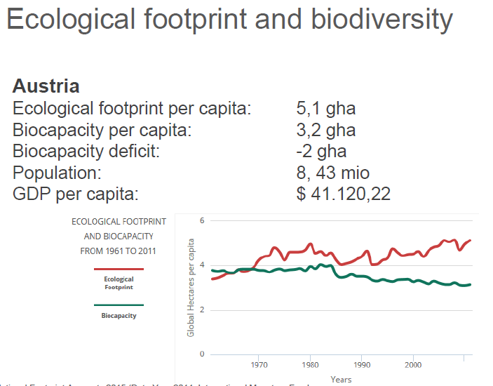1 gha represents the average productivity of all biologically productive areas on earth in a given year, this does not count deserts, glaciers and so on, using this information it is possible to calculate the relative **carrying capacity** of the earth.

This ecological footprint is highest for the western world as well as Australia.

#### Ecological debt day

This is the day at which humanity’s use of natural resources exceeds what the earth can regenerate in that given year, selected countries consume more than they generate.

#### Virtual Water (Water Footprint)

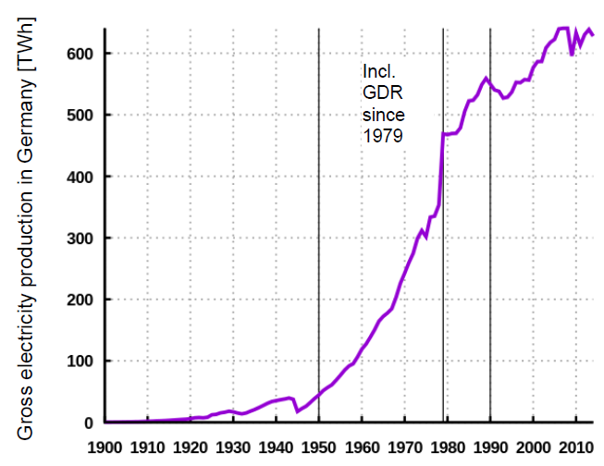This is a measurement that measures the total amount of fresh water used in order to produce a product or provide a service.

#### The 1950s syndrom

After the second world ware, global energy demand increased rapidly, starting in Europe where lifestyle and standards of living changed significantly. The **economic basis** for this is the price decrease of fossil fuels through newly discovered huge resource reserves in the middle east, this lead to an **increase** in **energy consumption** and a development of a consumer society.

## Environmental targets in companies

**Reasons for acting sustainable** include economic rationality, external pressure, competitive advantages as well as an ethical rationality, the **goals** are legitimacy and acceptance, increasing productivity and strengthening competitive positions.

It is beneficial to **reduce resource consumption, reduce emissions** as well as **deal with future environmental problems**, it is also better to go from pollution control to **pollution prevention strategies** by reducing or eliminating air, water and land pollution in an efficient and sustainable manner. This can save energy, protect the environment, conserve natural resources and tries in general to stop pollution before it is generated in the first place.

### Cleaner Production

**Cleaner Production** is similar to pollution prevention and is a process that continually evolves with the introduction of improved technology and innovative ideas.

*Cleaner production is the continuous application of an* ***integrated preventive environmental strategy*** *applied to* ***processes, products and services*** *to increase eco-efficiency and reduce risks for humans and the environment.*

This applies to **production processes** (conserving raw materials, eliminating waste…), **products** (reducing negative impacts along the life cycle of a product) and **services** (incorporating environmental concern into delivering services).

#### Objectives of cleaner production

1. **Increase efficiency by reducing pollution**
   1. Waste Reduction (try to achieve zero waste discharge)
   2. Non-Polluting production
   3. Production Energy efficiency
2. **Reduce risks for humans and environment**
   1. Safe and healthy work environments
   2. Environmentally sound products
   3. Environmentally sound packaging
3. **Reduce Costs**

Additional techniques include **improving process efficiency, substituting materials, controlling inventory, performing preventative maintenance, improve housekeeping** and **in-process recycling**.

#### Benefits of Cleaner production

**Environmental and social benefits** are to be expected by reducing the ecological damage from raw material extraction and refining operations and reducing the risk of emissions during production, recycling, treatment and disposal operations. It also reduces the risk of civil and criminal liability by minimizing the amount of waste generated.

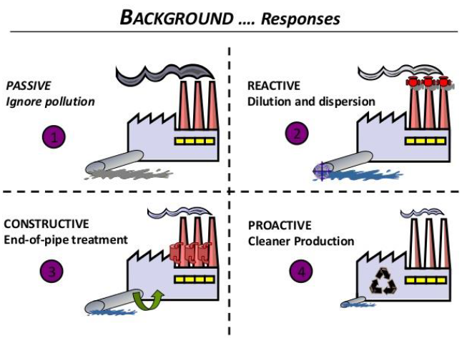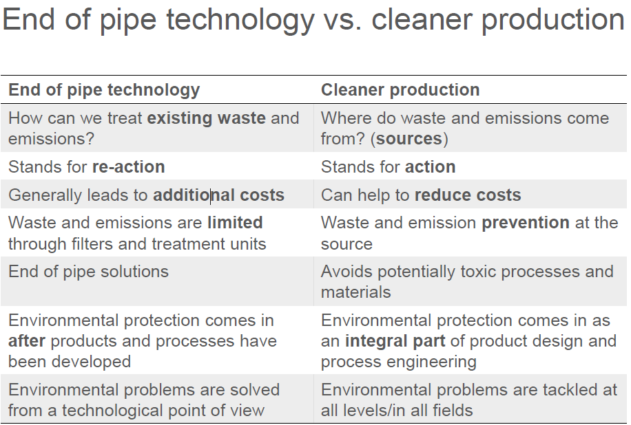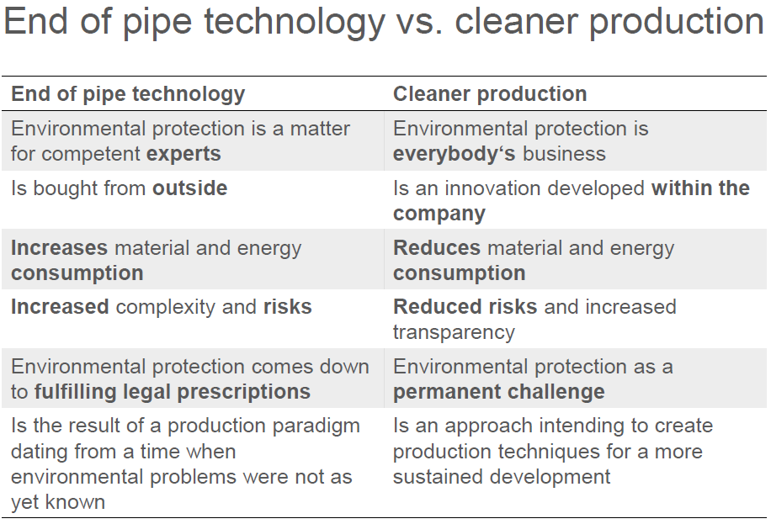**Economic benefits** are expected due to reducing operating costs, reducing material, energy and facility cleanup costs and also by improving a company’s image.

#### Environmental basic strategies

There are **passive environmental strategies** like considering environmental protection due to external pressure, as a reactive strategy or **active environmental strategies** like considering environmental protection a-priori in all relevant business divisions and through an active strategy of communication.

# Climate Change

First of all, it is important to distinguish between **weather** (conditions of the atmosphere over a short period of time, changes possibly several times a day) and **climate** (average of weather conditions over a long period of time), hence **climate change** are changes in long-term averages of daily weather, for example the **Milankovic cycles** that appear every 10.000 to 100.000 years.

*Climate change is change in the statistical distribution of weather patterns when that change lasts for an extend period of time.*

Its **cause** are biotic processes, variations in solar radiation received by the earth, plate tectonics leading to volcanic eruptions as well as **human activities**.

**Consequences** include

* Change in local climate
* More extreme weather events
* 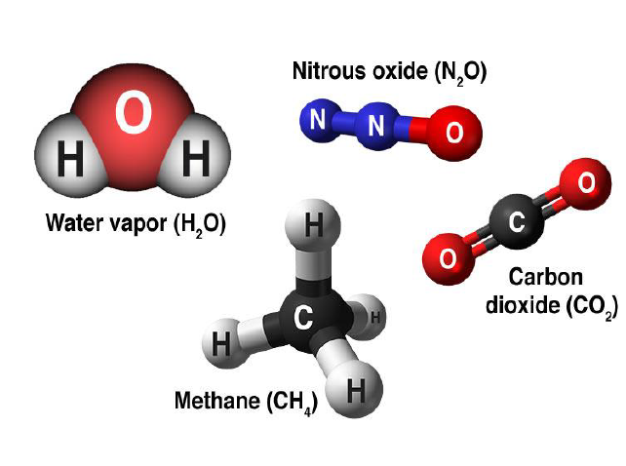Intensification of hydrological cycle
* Reduction of areas covered in snow and ice
* Sea level rise
* Loss of biodiversity
* Change in land use patterns

In our area, this means especially warmer and drier summers, melting of glaciers, higher pollution concentrations as well as change in crop/food production.

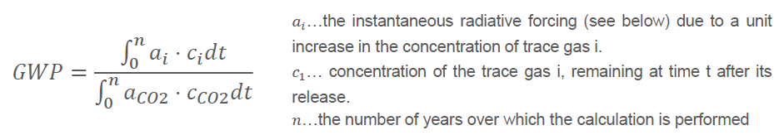The gases attributed to contribute to the greenhouse gas effect are the so-called **greenhouse gases**, carbon dioxide, methane, nitrous oxide, chlorofluorocarbons as well as water vapor.

## Global warming potential

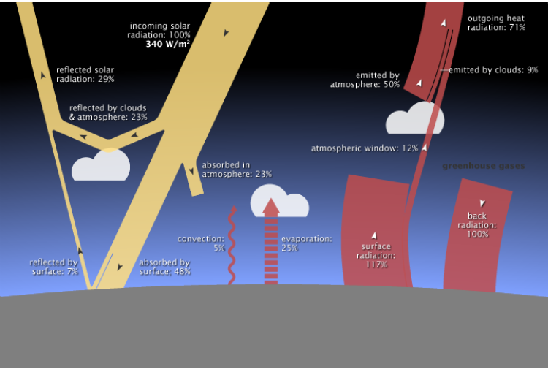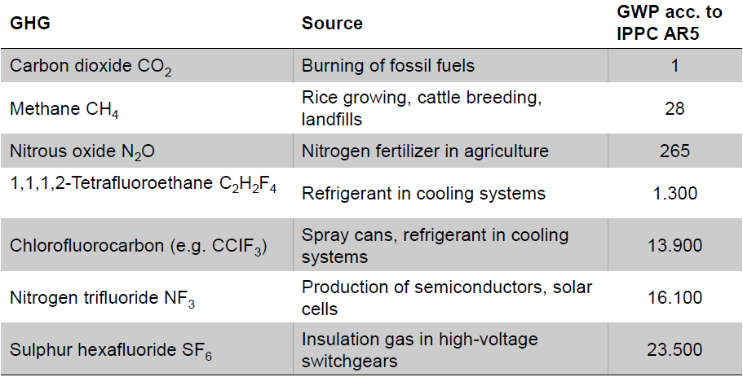The **global warming potential** is a relative measure of how much heat a greenhouse gas traps in the atmosphere, it compares the amount of heat trapped by a certain mass of the gas in question to the amount of heat trapped by a similar mass of CO2.

## Radiative forcing

*A process that alters the energy balance of the atmosphere system is known as a radiative forcing mechanism.*

Greenhouse gases block energy from going back to space, the graph shows CO2 emissions per sector.

In the last 100 years, temperatures on average rose by about 0.85°C, since 1900 almost every century was warmer than the preceding century, more heatwaves and heavy precipitation events are noticeable, while the number of cold days goes down while the number of warm days’ rises. The oceans are also impacted, sea level rose by nearly 20 cm in the last 100 years and surface temperature rose by 0.1°C per decade in the last thirty years.

This rise in sea level leads to a loss in land mass, ergo living space and agricultural areas, relocation programs will become necessary. If all the ice on the planet would melt, then the sea level would rise by about 70ms.

## Cryosphere

*The cryosphere describes all the earth’s surface that is covered in ice.*

Glaciers lost about 200 GT of ice per year in the last 40 years, the ice loss in the arctic also rose from 30 to 150 GT per year in the last years, the area covered by ice decreased from 11 mio km2 to about 6 mio km2. Greenland is rising by about 4cm a year, today it is covered to 85% by ice, this would lead to an increase in sea levels by about 7ms. The Antarctic is also affected, it has an ice layer of the thickness of 5km.

## Climate Targets

#### EU 2020 goals

The goal here is to lower GHG emissions by 20% compared to 1990, get a 20% share of renewables and 20% increase in efficiency.

#### EU 2030 goals

The goal here is to lower GHG emissions by 40% and get to a 27% share of renewables and 27% increase in efficiency.

#### 2°C target

Limiting global warming to 2°C about the pre-industrial level, to reach this target, all GHG emissions between 2045 and 2060 have to be zero, this goal was revised in Paris 2015 to limit preferably to 1.5°C.

## Impact on Electricity sector

The electricity sector is influenced both by weather (day-to-day operations) and climate (planning). Warmer summers mean a higher energy demand for cooling, on the other hand, warmer winters reduce the demand for heating.

With higher ambient temperatures, the efficiency of thermal conversion in **thermal power plants** is decreased and cooling towers are less effective, this leads to **reduced power output** or even **temporary shutdown** of such power plants.

**Hydro power plants** are also affected, as changing rain patterns and more evaporation due to higher temperatures lead to problems in run-off-river power plants, **hydro storage plants** also have to deal with the problem, that glaciers melt away and cannot fill up during the summer from the meltwater of the glaciers.

**Wind power plants** have to be able to deal with an increasing number of storm, during which they have to be slowed down to prevent damages.

**PV power plants** also suffer from an increase in clouds and **nuclear power plants** suffer from environmental destruction, that can harm infrastructure needed to cool down nuclear material, as seen in Fukushima.

In general, the energy sector is the biggest contributor to GHG emissions, if this sector does not change, climate change will continue to harm several areas, if it changes, big investments are needed in the near future.

# Emission Trading System

## Emission trading

**Emission trading** sees pollution as a **negative externality**, meaning an economic activity that affects a third party negatively, the goal therefore is to put a price on carbon to provide an economic incentive to reduce emission, beginning with the lowest-cost opportunities. In general, there are **3 alternatives**, carbon tax, cap-and-trace and command-and-control regulation.

### Carbon tax

This is an **incentive-base regulation**, it can be done two ways, either by directly taxing CO2 or put a surcharge on the carbon content of fossil fuels to discourage their use. It is a **price control instrument** that sets the price of carbon, the quantity then is defines by the market, the magnitude of the tax depends on how sensitive the supply of emissions is to the price.

### Cap-and-trade

This is a **quality control instrument** that puts a cap on the total amount of GHG that can be emitted by all participating installations, allowances for emissions are then auctioned off or allocated for free, these can also be traded. The **quantity** here is set and the market determines the price, it is also an **incentive-based regulation**.

### Command-and-control regulation

This is a system of regulation that prescribes emission limits and compliance methods on a facility-by-facility or source-by-source basis, it is less flexible and can for example set a **performance standard**, where the emission goal for each polluter is fixed, so the burden of reducing pollution cannot be shifted to other companies, so this is not so cost effective, production costs would rise and this cost would be passed on to the consumer.

## Kyoto protocol

The **Kyoto Protocol** is an international agreement which was adopted 1997 in Kyoto (Japan) and entered into force in 2005. It commits its parties by setting internationally binding emission reduction targets, the goal was first to reduce GHG emissions to an average of 5% against 1990 levels with a higher burden on developed countries and common but differentiated responsibilities. The first commitment period was between 2008 and 2012 and then the second is from 2012 to 2020, where the goals were revised to a reduction of at least 18% and new gases are defined as **Kyoto gases**, these are:

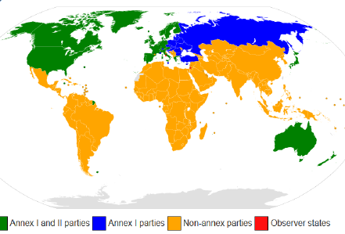*CO2, CH4, N2O, HFC, PFC and SF6*

Parties are classified into different categories, the **Annex I** countries, which are the industrialized countries and economies in transition (EIT), the **Annex II** countries, which are the OECD members, required to provide financial support to EITs and assist them in reducing GHG emissions. **Non-Annex** countries are mostly low income developing countriesand **Annex B** countries with emission reduction commitments.

## Mitigation & Adaption

There are two ways of dealing with climate change, **mitigation & adaption**.

##### Mitigation

Here, actions are taken to limit the magnitude or rate of long-term climate change, human (anthropogenic) emission of GHG are reduced, the capacity of carbon sinks (e.g. deforestation) is increased and the switch is made to low-carbon energy sources, energy efficiency.

##### Adaption

Here, the goal is to manage the impacts of climate change by reducing the vulnerability of social and biological system to climate change and offsetting the effects of global warming. Local planning is necessary and changes to agricultural production.

## Mechanisms

Countries must meet their targets primarily through national measures, in general there are **3 mechanisms** to do so, International emissions trading, Clean Development mechanism and joint implementation.

### International emissions trading

**International Emissions trading** enables trade between Annex-B states, if countries have too much emission units, they can sell this excess capacity to other countries that otherwise would be over their reduction targets, the **trading unit** is AAU (assigned amount units) and equals one ton of CO2 reduced. The **market clearing price** results from **offer and demand**, it follows the economical principle **cap and trade**, where an aggregated cap on all sources is established, which is reduced over time, these emission allowances can be traded.

### Clean Development Mechanism (CDM)

Here the goal is emission reduction between **Annex I** and **Non-Annex I** countries, this allows a country with an emission reduction commitment to implement emission reduction projects in developing countries, the goal here is **technology transfer and development** to decrease emissions in the investor country and support the host country in sustainable development. The investor country receives a saleable **Certified Emission Reduction (CER)**, which also equals one ton of CO2.

### Joint implementation (JI)

The goal here is **emission reduction** between **Annex I** countries by implementing an emission reduction measure in the host country, the investor country receives emission allowances, these allowances move from the host country to the investor country, the investing country receives an **Emission Reduction Unit (ERU)**, which also equals one ton of CO2.

### Problems

Problems include **conflicts within the umbrella group**, as climate change actions affects economic growth and China/India/South Korea are not participating in the Kyoto protocol. The EU takes a pioneering role and adopts the **Burden-Sharing-Agreement** by redistributing the sum of their original reduction targets inside the group, by this it can take member states’ individual conditions into account.

Another problem is that there is **no incentive** for conservation or preservation and also **not reduction obligation** for undeveloped countries. Also, **China** is the world’s second largest emitter and continues to rather decrease their population count instead and the **USA,** as the world’s largest emitter, never ratified the protocol.

## COP 21

This is the 2015 Paris agreement, the objective was to get a **binding and universal agreement**, from all nations on the world as a follow-up to the Kyoto protocol, the **goal** was to reduce anthropogenic GHG emissions to limit global temperature increase to 2°C (preferably to 1.5°C) above pre-industrial levels, to reach this goal, emissions have to be 0 between 2045 and 2060.

195 member states have to ratify the protocol and the treaty is binding according to international law, but now penalties are enabled for violations. The key role lies with China and the US, financially less strong states are supported starting 2020 until 2025 for adaption and mitigation measures.

###### pROBLEMS STILL

The basic problem remains that fossil fuels are too cheap and do not reflect scarcity, financial support for developing nations may not be enough, aviation and shipping were not considered, there are no specific CO2 reduction commitments for each country and also no penalties for violations.

## EU Emission trading system

The goal here is to establish a scheme for greenhouse gas emission allowance trading within the EU based on the cap-and-trade principle. Starting in 2005 it includes all six GHG and considers credits from JI- and CDM-projects, this means that about 45% of total GHG emissions from EU countries are covered.

All plants have an obligation to monitor and report their output and financial penalties are handed out to those not fulfilling reduction targets. Every state is responsible for the distribution of the certificates to the national facilities. The total quantity of certificates is decided depending on the **National Allocation Plans (NAP)** that have to be in accordance with the reduction targets of the respective state.

Industry there for can reduce its output, increase productivity, shift production or purchase more emission allowances to hit their goals, the decision criterion is typically the least cost option.

###### 1st trading period 2005-2007

95% of the allowances were free, 5% were available via auctioning, the reduction targets were according to climate strategy until 2010.

The allocation of emission allowances is done according to **grandfathering** (allocation based on past emissions) and **free reserve** is reserved for new market participants and plant expansions according to ‘first come – first serve’. The total quantity of certificates is calculated for each sector.

The **biggest problem** was the **huge over-allocation** of emission allowances, this lead to a steep price drop.

###### 2nd trading period 2008-2012

This coincides with the 1st commitment period of the Kyoto protocol, these target should be reached. Also, new participants are added and now at least 90% are allocated for free and the general goal is to achieve scarcity.

Some **changes** were made, mission emission allowances can now be compensated by CDM and Ji projects, more plants are included and also about 10% of all available emission allowances can be auctioned.

###### Conclusion of the 1st and 2nd period

**Too much** certificates were allocated for most EU countries, reasons for this are that too less information was available, lobbying also played its part. Another problem was, that the **flexible reserve** was too small for the power plants constructed in the 2nd period, also **windfall profits**, meaning additional profits for electric utilities by increasing the electricity tariffs due to emission trading in spite of the free allocation of emission allowances.

###### 3rd tradind period 2013-2020

Now, a **single EU-wide cap** on emissions is introduced instead of national caps, this cap should be decreased annually and the target for 2020 is an emission reduction by 79% compared to 2005, the allocation happens based on benchmarks, so according to pre-defined emission values for the production of single products.

Also, more sectors and gasses are included and free allocation is replaced by **auctioning**, starting with 20% for auctioning up to 100% after 2020. **Electric utilities** do not get free allocation anymore.

**Environmentally friendly companies** should be **rewarded** with free emission allowances and also export-oriented companies get free emission allowances, if their production costs would rise by more than 5% due to emission trading and achieve more than 10% of their revenue due to export outside the EU.

###### 4th trading period 2021-2030

The goal is to **increase the speed of emission cuts**, sectors have to reduce their emissions by 43% compared to 2005, emission allowances should go down by over 2% annually starting 2021 and additionally should be reduced by 500 mio tons.

Also, the system of free allocation should be revised to focus on sectors with the highest risk of relocating their production and more flexible rules should be introduced to better align the amount of free allowances with production figures and updating benchmarks to reflect technological advances since 2008.

**Funding** should be introduced for **innovation and modernization** via an **innovation fund** (extend existing support of innovative technologies) and a **modernization fund** (facilitate investments in modernizing power sector and boost energy efficiency in lower-income member states).

# Life-Cycle Analysis

## Material flow management

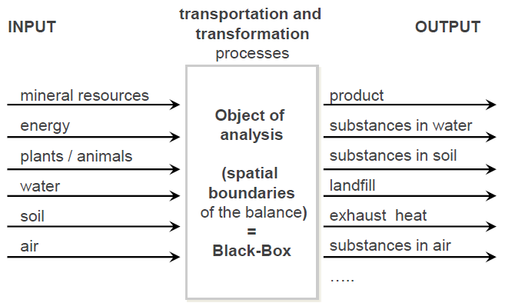The goal of material flow management is to **efficiently manage** materials in an economic and ecological sense, trying to save on costs, as material costs are often the biggest cost factor in the manufacturing sector. **Scarcity** of resources leads to rising costs and lowering this cost is essential in order to remain globally competitive.

By accounting for material and energy entering and leaving a system, mass flows can be identified which might have been unknown or difficult to measure.

The sum over all mass and energy flowing into the system is equal to the sum over all mass and energy flowing out of the system, the 1st law of thermodynamics.

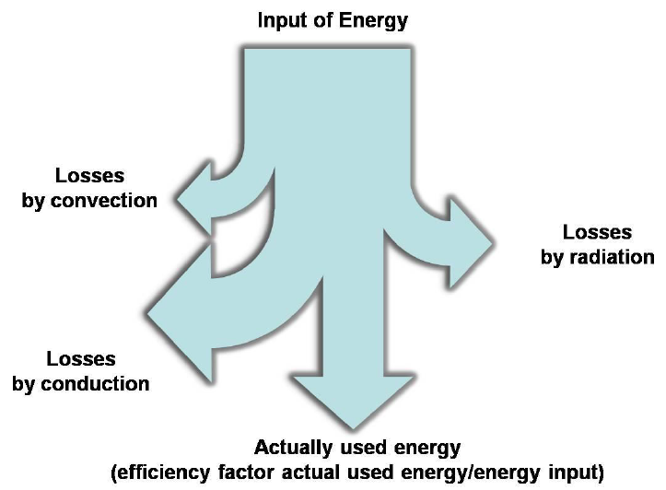This mass/energy balance considers the balance of flows in and out of the system as well as the balance of stocks. So-called **Sankey-Diagrams** can be used to visualize such energy flows.

### System Boundaries

Boundaries exist between the technological system and nature, but also geographically or even between current life cycle and related life cycle of other technical systems.

Sources of information regarding material and energy balances can be found in cost-accounting, accounting, asset management and obviously through measurement and observation.

## Life cycle assessment (LCA)

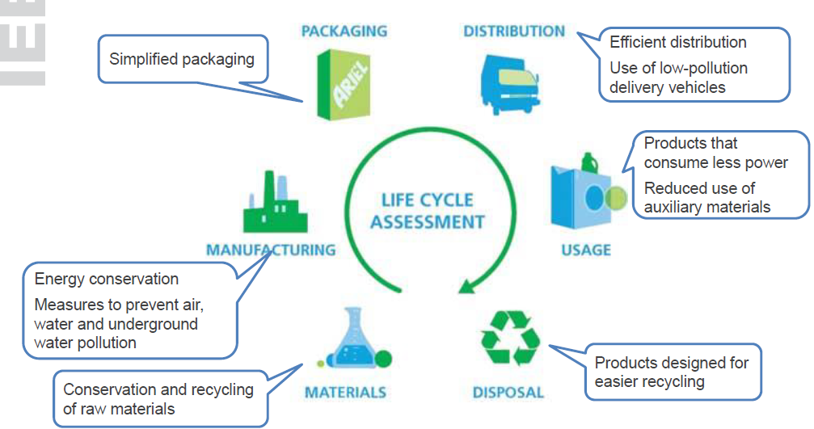*Live-cycle assessment is a technique to assess* ***environmental impacts associated with all the stages of a product’s life*** *from raw material extraction through material processing, manufacture, distribution, use, repair as well as maintenance, disposal or repair.*

It is also known as eco-balance (Öko-Bilanz) or cradle-to-grave analysis, here it is discussed in accordance with ISO 14040/14044.

### Goal and scope definition

The **goal** is to define the **intended application**, the **reasons** for conducting the study as well as the **intended audience** and form of communication.

The **scope** defines a **functional unit**, which acts as a reference to which inputs and outputs can be related, certain assumptions and limitations are assessed and a critical review and other procedural aspects are thought of.

### Inventory analysis

**Inventory analysis** is the **data collection part** of LCA, it is the phase involving **compilation and quantification of inputs and outputs** for a given product system throughout its life cycle. It involves creating an inventory of flow from and to nature for a product system. Typical steps are

1. Preparing for data collection
2. Data collection
3. Calculation procedures
4. Allocation and recycling

### Life cycle impact assessment

The objective is evaluating the significance of potential environmental impacts based on the LCI flow results, it consists of the following mandatory elements

1. Selection of impact categories, indicators and characterization models
2. **Classification stage**, where inventory parameters are sorted and assigned to categories
3. impact measurement, where the categorized LCI flows are **characterized**, using one of many possible LCIA methodologies
4. then summed to provide an overall impact category total (**normalization**)

Under the ISO definition in the **classification stage**, the LCI results are assigned to their impact categories (CO2 to climate change, copper to water eco-toxicity).

In the **characterization** (calculation of category indicator results), the impact is measured.

In the **normalization stage**, the magnitude of category indicator results to reference information is calculated, this reference information (over a given period of time) is for example the area of use, the person, the product and so on.

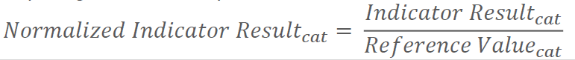The **aim** is to better understand the relative magnitude for each indicator results of the product system under study by checking for inconsistencies, providing and communicating information on the relative significance of the indicator results and preparing for additional procedures.

There are several **methods for environmental impact assessment**, including **qualitative evaluation methods**, **quantitative, non-monetary evaluation methods** as well as **quantitative, monetary evaluation methods**.

## CML

It evaluates the impacts of emissions on environmental issues/impact categories, it is an **impact-oriented classification**, where emissions are classified by environmental impact categories (climate change, acidification, human/eco toxicity…)

#### CML Example

1. Selection of the considered environmental impacts
   1. Emission of 1000t CH4
2. Classification by a certain environmental impact category (**classification**)
   1. Greenhouse effect
3. Form index values for each category (**characterization**)
   1. Greenhouse effect with Global warming potential
   2. CH4 21 times stronger than CO2
4. Compare to benchmarking value (**normalization**)
   1. Austria 93*106 t CO2 equ
   2. Share of our emission: 2.3 * 10-4 CO2 equ

## Cumulated Energy demand

Energy is view as a measurement for the environmental impact, the total amount of primary energy required during the production, use and disposal of a product or service or the required amount of energy originally related to a good is called **CED (cumulated energy demand)**.

## Eco-points/ecological scarcity method

Energy and material flows refer to ecological scarcity, the **eco-factors** express the distance between the current and the target state in regard to the respective substance, the less eco-points a process causes the better its ranking.

## MIPS (Material Input per service)

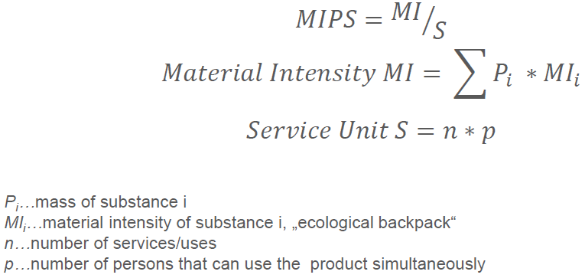Environmental issues are related to the extent of material flows, MIPS is a measure of raw material intensity.

## Eco-Indicator 99

This is a **damage oriented environmental impact assessment**, it uses three types of damages as indicators, **human health** (measured in disability adjusted life years, includes deaths and illnesses)**, quality of ecosystems** (biodiversity or loss thereof) and **resources**.

## Sustainable Process Index (SPI)

Was developed at the TU Graz and is based on the assumption that a sustainable society is built only on solar exergy, surface area is needed for the conversion of energy into products and services, this area is the underlying dimension of SPI, more area leads to more cost. An SPI between 0.001 and 1 can be used for sustainable development, over 1 means it is too inefficient for sustainability.

To calculate it, all partial footprints calculated by the mass and energy inputs/outputs are added up, the result is the overall ecological footprint Atot.

## Life Cycle Assessment of PV systems

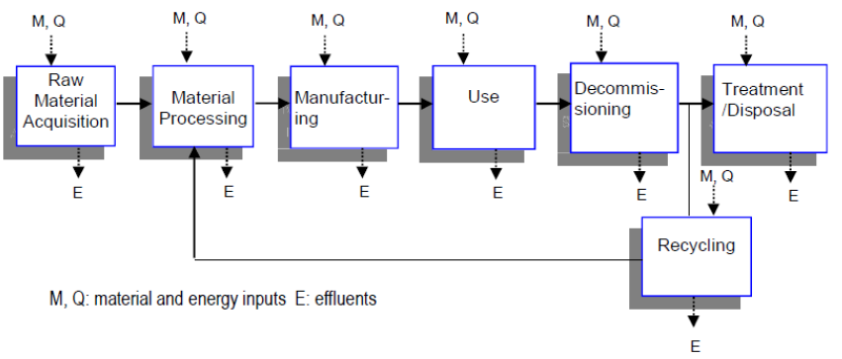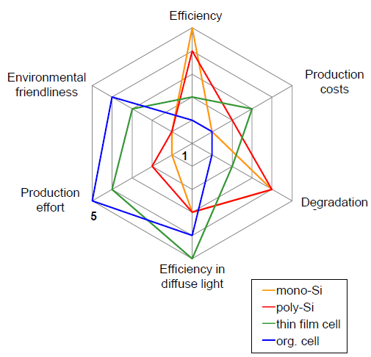4 different technologies are discussed, mono- and multi-crystalline Si, CdTe and high concentration PV.

The advantages and disadvantages of the different cell technologies are

* Mono-Si
  + High efficiency (25%) but high production effort
* Multi-Si
  + Low production effort
* Thin film cells CdTe
  + Advantages in diffuse light
* Organic cells
  + Low material losses during production but degradation in the first 1000h

The following assumptions are made, that we deal with roof mounted PV systems with a performance ratio of 0.75, 30 years’ life time and southern European irradiation.

### energy Payback Time

This is the period required for a renewable energy system to generate the same amount of energy that was used to produce the system itself.

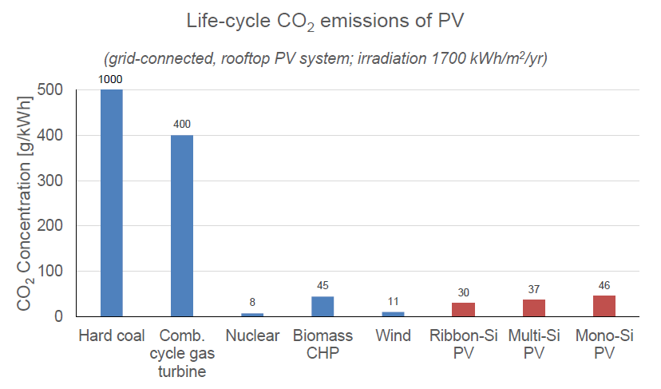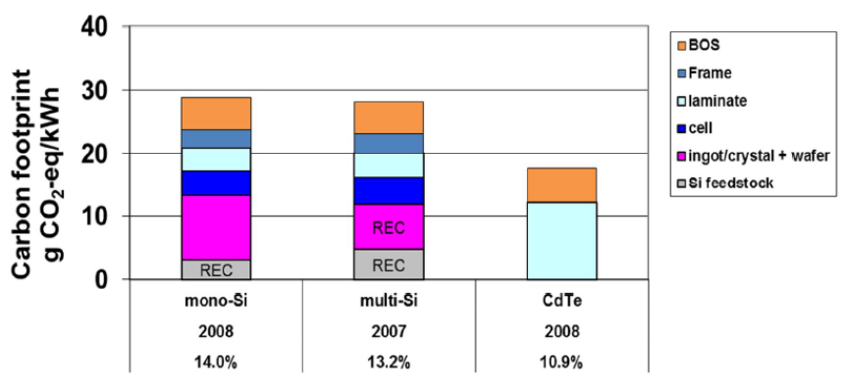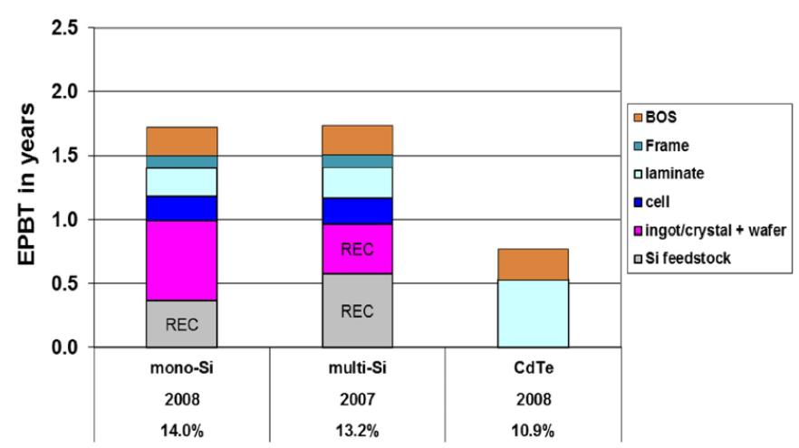

# Environmental & Energy Management Systems

## Development of environmental protection

**Environmental protection** is the practice of protecting the natural environment on individual, organizational or governmental levels to benefit humans and the natural environment. It deals with **waste production, air pollution** and **loss of biodiversity**. Often, the role of government is a big focus via legislation and law enforcement.

The objective is to ensure compliance with law and regulations **today** and work on the operational level with end-of-pipe technology (additive environmental protection) and filters, **in the future** on the strategic level with front-of-pipe technology (integrated environmental protection) and with environmental management systems.

An important point is **environmental awareness**, which is changing as environmental damage affect air, water and finite resources start to become a problem, hence **environmental protection** demands responsible behavior of each individual and a common approach on an international level.

##### Eco-Efficiency

Is a tool to promote a transformation of sustainable development and is given as the fraction of economic divided by ecological performance, in the sense of adding value without accidents, less resources and reduced environmental pollution.

## management Systems

**Management systems** ensure that an organization can fulfill all tasks required to achieve its objectives, which can be assessed at every phase and leads typically to an improvement of the operational and organizational structure of the company. It works by **establishing responsibilities, determining accountability** in action plans and **assessing** the system **objectively**.

The aim is that such a system ensures that the products or services of a company meet the **organization’s objectives,** such as satisfying the **customer’s quality requirements**, complying to **regulations** or meeting **environmental objectives**.

To be really efficient and effective, the organization can manage its way of doing things by **systemizing** them and handing out **clear responsibilities** and providing an international, state-of-the-art **model** to follow.

Top Down principle

An observed system is defined and this is then restricted to the most important details, the obtained findings need to be incorporated in the management system *bottom up*.

###### Principles for designing mangement systems

* Holistic nature
* Modularity and openness for other systems
* Simplicity and intelligibility
* Neutrality regarding functionality orientation
* Flexibility and adaptability to environmental conditions
* Feedback loops
* Innovation support and dynamic

## Environmental management Systems

These help organizations to implement environmental management policies and identify and control the environmental impact by improving the environmental performance.

###### Costs

**Costs** stem from public relations, certification fees, consulting, time expenditures, information procurement…

###### Benefits

**Benefits** are the **reduction of** environmental risks and fines due to that, **improvement of** employee’s health, credibility against public and **recognition of** cost reduction potentials, necessary training of employees.

### ISO 14001

This is a voluntary international standard published by ISO, it specifies requirements of an environmental management system (EMS) and is not used for a single product or process, but a **generic standard** that can be applied to **any organization** or any **sector**, whether it is a business enterprise, a public administration or a government department.

It is used for **environmental management** and looks at what the organization does to **minimize harmful effects** on the environment caused by its activities, to conform to applicable **regulatory requirements** and to achieve **continual improvement** of its **environmental performance**.

Used for processes -> not products or services

#### Certification

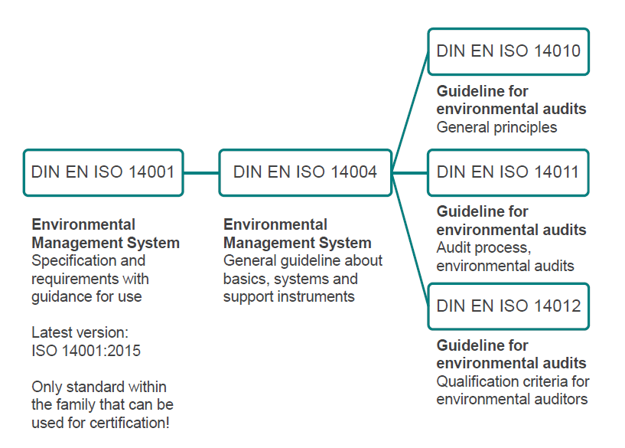An **independent, external body** audits an organization’s EMS and verifies that it conforms to the requirements specified in the standard, it **does not carry out** the certification and does not issue or approve certifications or accredit, approve or control certification but it **develops standards and guides to encourage good practice** in accreditation and certification.

##### Accreditation

This is like the certification of the certification body and is a formal approval by a specialized body that a certification body is competent to carry out certification in specified business sectors. **Accredited certificates** issued by accredited certification bodies may be perceived on the market as having increased credibility.

**Certification is a business decision, not a requirement**, therefore it is a decision to be taken for business reasons. Advertisement is only allowed with certification.

### Coninuous improvement process

It is based on the **Plan-Do-Check-Act-Cycle**.

##### Plan

In this phase required objectives and processes are established with an initial review to identify **environmental aspects** and **establish measurable** environmental **objectives, goals** and **targets**.

##### Do

Here the processes are implemented and required resources and responsibilities are identified and procedures and processes are established.

##### Check

Here, the performance is measured and monitored and the results are reported, this ensures that environmental target and objectives are being met and internal audits are performed.

##### Act

Now it is time to improve performance based on these results and the management is being review.

#### Benefits

* International, expert consensus on state-of-the-art practices for environmental management
* Common language for dealing with customers and suppliers
* Improved communication
* Model for continual improvement
* Reduced costs through increased efficiency, effectiveness

#### Potential limitations

* Implementation can be time consuming/expensive
* Continuous process -> continuous work
* Resources needed

### EMAS

**EMAS** (Environmental Management and Audit Scheme) was developed by the European Commission and is used to **assess, manage** and continuously **improve environmental performance**, the **aim** is to recognize and reward organizations that go beyond minimum legal compliance and improve environmental performance. This is voluntary and globally applicable for all types of organizations.

It is now in its 3rd iteration, first it was only restricted to companies in industrial sectors, then became open to companies from all economic sectors including public and private services, also the integration of ISO 14001. With the 3rd iteration it became globally applicable, not only EU member states, it holds obligatory key performance indicators to harmonize reporting on environmental performance.

It goes beyond the scope of ISO 14001 and tries to involve employees and others to benefit from their commitment and is implemented as a continuous improvement process. The four main stages to achieve EMAS registration are:

1. Conduct an **environmental review** of all activities and assess them against existing environmental laws
2. Establish an **environmental management system** setting out the environment objectives and the means to achieve these objectives
3. Carry out an internal **environmental audit** assessing the management system in place and compliance with relevant environmental regulatory requirements
4. 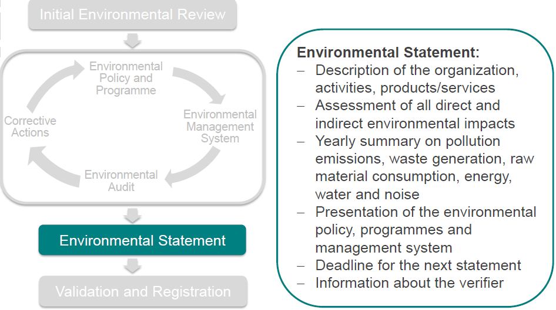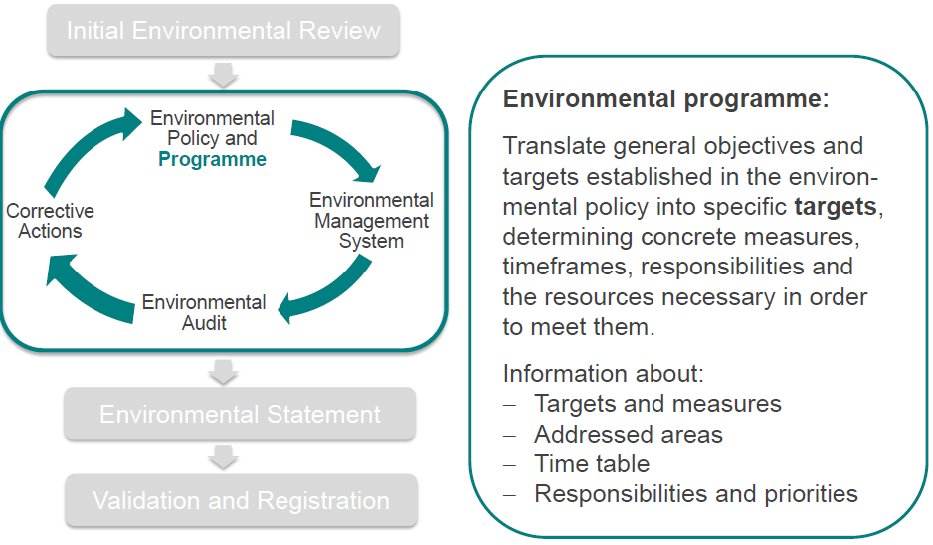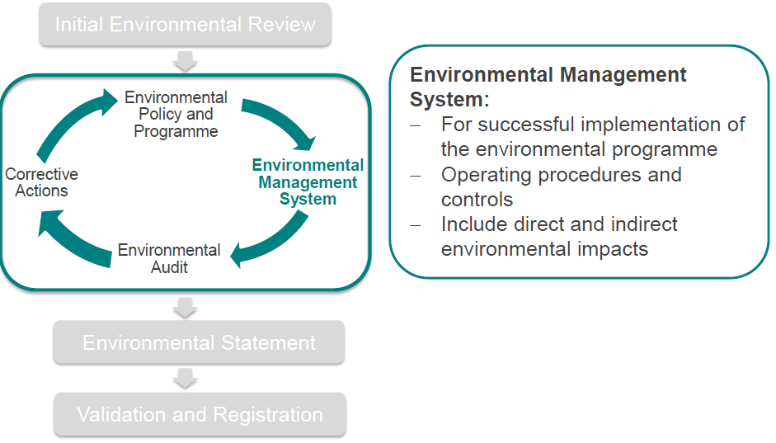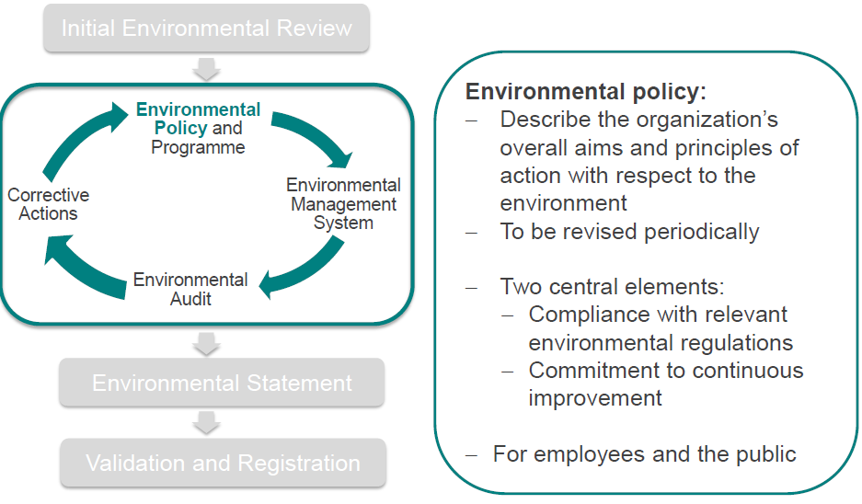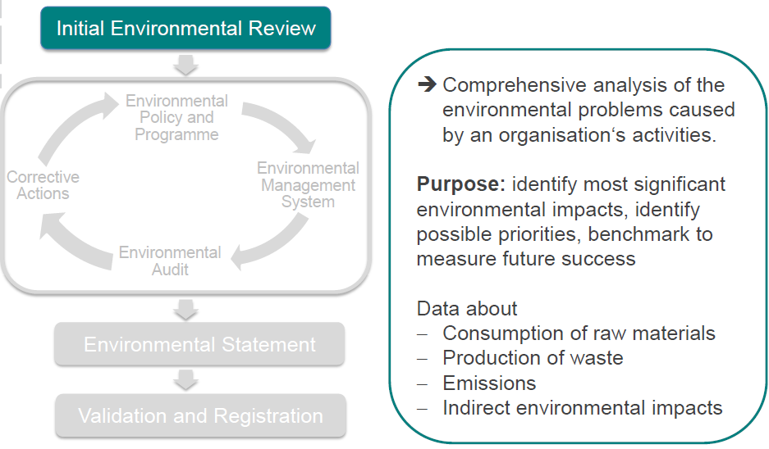Provide a **statement** outlining the environmental policy, program and management system and summarizing the environmental performance with the results achieved and the steps necessary for future improvements

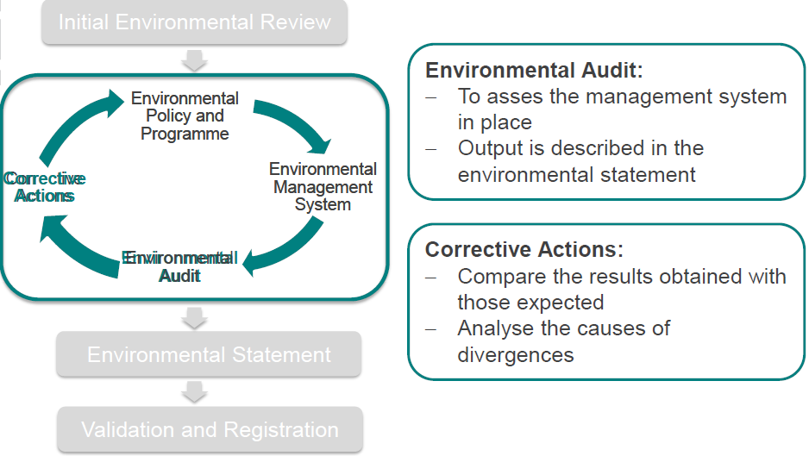

#### Benefits

* Use EMAS logo to promote an organizations active involvement in environmental issues
* Environmental benefits
* Communicate environmental accountability to stakeholders
* Continuous improvement
* Involve employees

#### Limitations

* Expensive
* Complicated or labor intensive
* Only looks at environmental impact, not social or economic

Verification is performed by an **environmental auditor** that gets admission at a notified body and is supervised by the notified body.

### Differences EMAS – ISO14001

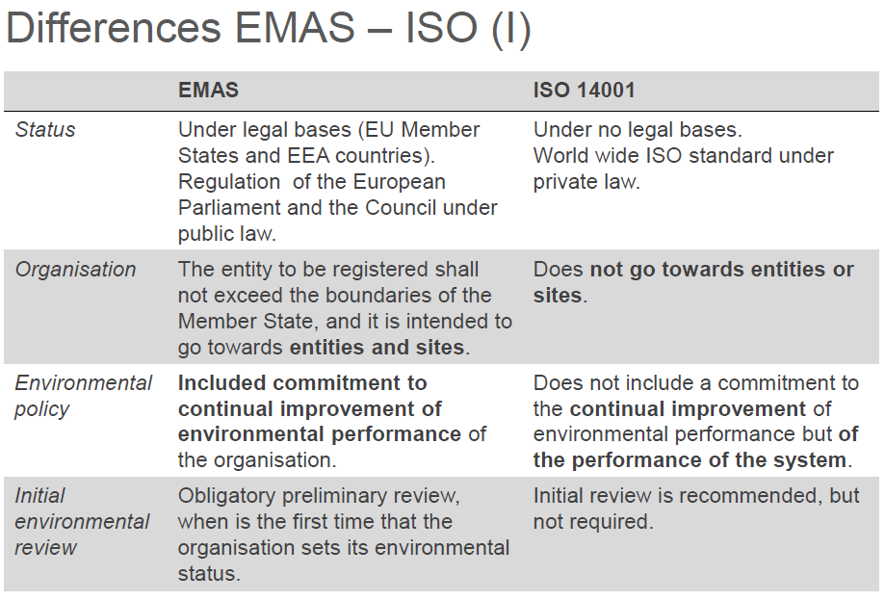The ISO standard is a subset of EMAS, as EMAS goes beyond the scope of ISO 14001 as legal compliance is a minimum requirement, the continual improvement of the environmental performance is key and open dialogue with stakeholders is necessary as well as involvement of employees.

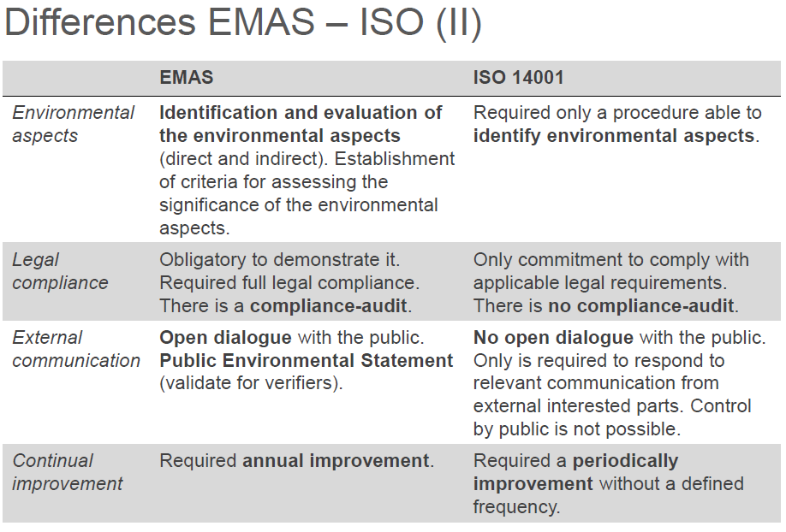

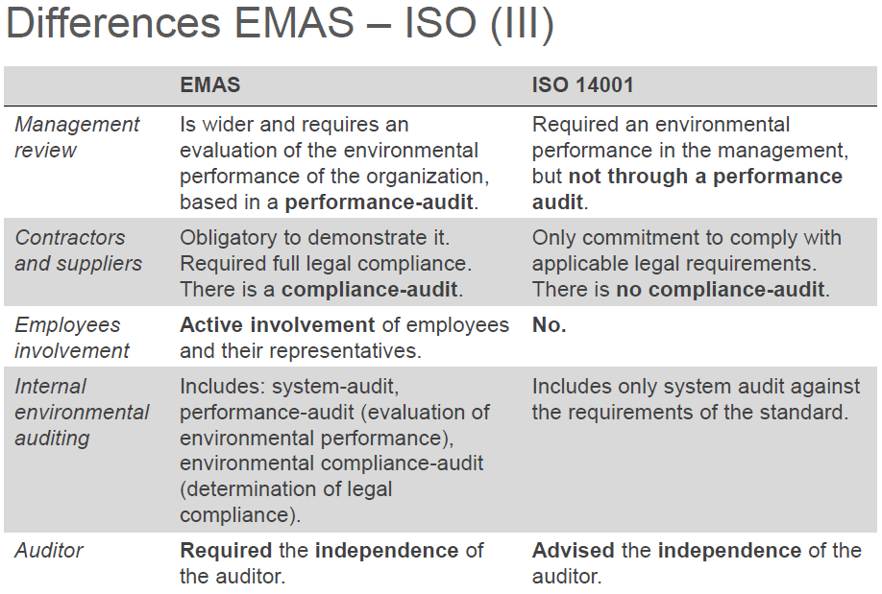

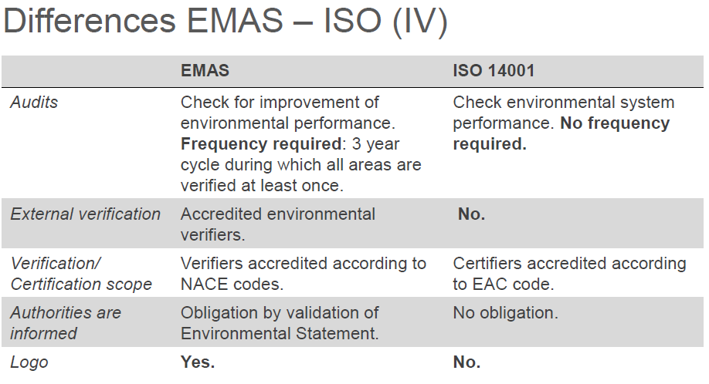

## Energy management System (ISO 50001)

This standard was released in 2011 and holds the requirements for establishing, implementing, maintaining and improving an energy management system. The purpose is the systematic approach in achieving continual improvement of energy performance. It is a generic standard and can be applies to any organization in any sector and any geographical location. It follows ISO 14001 and instead of trying to just improve the effectiveness of the management system, it tries additionally to improve the resulting energy performance.

The **aim** is to reduce the amount of energy consumed, particularly important for energy-intensive companies, drivers for this are the need to reduce costs, increase competitiveness, improve public image, environmental protection or sustainable management.

An **energy management system** records the energy flux and is the basis for investments in improving energy efficiency. It tries to continuously and systematically improve the energy performance.

An **energy policy** is the starting point for a functioning EnMS and sets out energy-related guidelines, operating principles and long-term overall objectives for the company, it also includes the **commitment** of top management to continuously improve the energy efficiency.

### Certification

Having a **certificate** increases the relevant of the EnMS and improves the image in general, an independent external certifier approves compliance of EnMS with requirement of ISO50001.

There are also annual audits by the certifier and re-certification before the validity of the certificate expires.

These certifications can be communicated externally to highlight the credibility of the company’s energy policy; it is possible to include the certification in the marketing strategy.

Important, ISO50001 is no product standard.

# Directives

# Acceptance